Blue marlin (Makaira nigricans) catch and size data of Taiwanese fisheries in the Pacific Ocean

Zi-Wei Yeh and Yi-Jay Chang

Institute of Oceanography, National Taiwan University, Taipei, Taiwan
Email: yjchang@ntu.edu.tw

Abstract

Blue marlin (Makaira nigricans) is a highly migratory pelagic species widely distributed throughout the Pacific Ocean and assessed as a single Pacific-wide stock. This study compiles updated fishery-dependent information on blue marlin catches and size composition from Taiwanese fisheries operating in the Pacific Ocean to support ongoing stock assessment efforts. Nominal catch data were assembled from official statistics, logbooks, landing declarations, and market records for distant-water tuna longline, offshore longline, and coastal fisheries. Size data, expressed as lower jaw fork length (LJFL), were obtained from onboard sampling and logbook records. The average annual blue marlin catch during 2009 – 2024 was approximately 5,310 metric tons, with offshore longline fisheries contributing the majority of catches, primarily from the North Pacific Ocean. Catches from the distant-water tuna longline fishery increased after 2000, while coastal fisheries accounted for only a small proportion of total landings. Length-frequency analyses for 2009 – 2024 showed relatively stable size composition, with most individuals ranging from 150 to 200 cm LJFL and limited interannual or seasonal variation. Mean LJFL remained consistent over time, although sample sizes declined in recent years and juveniles (<100 cm LJFL) were rarely observed. These updated catch and size data provide essential inputs for regional blue marlin stock assessments.

Keywords: fishery information, catch and length data, blue marlin, Taiwan

Introduction

Blue marlin (Makaira nigricans) is a highly migratory species which inhabits widely in the Pacific Ocean between the latitudes of 45°N and 45°S (Molony, 2008). Based on genetic analyses (Graves and McDowell, 2003) and fishery- dependent catch-rate data (Kleiber et al., 2003), blue marlin has been considered a single stock in the Pacific Ocean. The foregoing assumptions have also been confirmed by tagging experiments, which have demonstrated that blue marlin migrate over long distances throughout the Pacific basin (Hinton, 2001). This paper aims to provide updated available fishery data for blue marlin caught in the Pacific Ocean by Taiwanese fisheries, including catch estimates by fishery and size frequency data in lower jaw fork length.

Materials and methods

Nominal catch data of blue marlin by fisheries in the Pacific Ocean were compiled from the Oversea Fisheries Development Council (OFDC), as well as the Taiwan Fisheries Yearbooks. For the Taiwanese distant-water tuna longline fishery, the blue marlin catches were estimated based on recovered logbooks, commercial data (before 2014), and landing declaration data (after 2014) (Fisheries Agency, 2025).

For the Taiwanese offshore longline fishery, the blue marlin catches were estimated based on the landing records from local fishing markets due to a low recovery rate of logbook in early years. Landing reports from foreign ports for the offshore longline fishery have been available since 2000 (Su et al., 2014), and the blue marlin catches can be further estimated. However, the information on those landing reports was retrieved without location information between 2000 and 2002. After 2016, all offshore longline fishery vessels operating outside the EEZ of Taiwan are required to report their daily fishery data through the e-logbook system. And the blue marlin catches of those offshore longline fishery vessels were estimated based on logbooks and landing declaration data as the data reporting requirement of Taiwanese distant-water tuna longline fishery. Catch information of the coastal fisheries such as gillnets, set-nets, and harpoons were compiled from municipal fishery data collection system.

The size data, length and weight (after 2009) of individual catch of all species are compiled from the first 30 fish caught for each setting recorded on logbook since 2003. The size data were collected through on-board sampling, in which the measurement was carried out by fishermen. Since 2017, weight frequency was reported instead of length data as size data to ISC.

Results and discussion

Blue marlin catch estimates of Taiwanese fisheries in the Pacific Ocean are summarized in Table 1, and the average annual catch from 2009 to 2024 is 5,310 M.T. Most of the blue marlin catch came from the offshore longline fishery (Table 1 and Figure 1), and most of them were caught in the North Pacific Ocean (Table 1). The blue marlin catches of the offshore longline fishery have gradually increased from about 900 M.T. in the late 1950s to about 4,000 M.T. in the 1990s. Since landing reports from foreign ports have been collected after 2000, the blue marlin catches increased by 3,066 - 4,375 M.T. in the early 2000s with a decreasing trend to about 2000 M.T after 2006. It should be noted that, as mentioned in the “Materials and methods”, landing reports from foreign ports have incomplete information between 2000 and 2002, and these catches have not been disclosed in National Report of Chinese-Taipei of the ISC (Fisheries Agency, 2025).

The second largest blue marlin catches came from the distant-water tuna longline fishery (Table 1 and Figure 1). With the development of deep freezer of this fishery since 2000 (Liu et al., 2015), there is an increasing trend in catches of blue marlin from this fishery. It can be explained with the characteristic of blue marlin prefers to inhabit the tropical warm waters of temperature above 26˚C (Block et al., 1992).
In contrast, very small catches of blue marlin were taken from the coastal fisheries, e.g. coastal gillnet, coastal set-net, coastal longline and coastal other fisheries (Table 1 and Figure 1), with harpoon fishery being the primary source of blue marlin catch among them.

Lower jaw to fork length (LJFL) frequency distributions of blue marlin catch of the Taiwanese distant-water longline fishery in the Pacific Ocean during 2009 - 2024 is shown in Figures 2 and 3. The results indicated that the annual and seasonal variations in BUM length were minor, with most individuals ranging from 150 to 200 cm. In some periods, such as the second quarter of 2014 and 2023, and the first quarter of 2024, the length composition was smaller.

Table 2 provides summary information on blue marlin lower jaw fork length from 2009 to 2024. Except for the higher sample size (10,215) observed in 2010, the sample sizes showed a marked decline in the recent four years, all below 3,000. The mean length of the measured catches was relatively stable (ranged from 172.8 to 186.8 cm LJFL) during 2009 - 2024. However, the blue marlin with LJFL less than 100 cm were not found in 2014, 2016, 2023, and 2024.

References

Block, B.A., Booth, D.T., Carey, F.G. (1992). Depth and temperature of the blue marlin, Makaira nigricans, observed by acoustic telemetry. Marine Biology., 114, 175-183.

Fisheries Agency. (2025). National Report of Chinese-Taipei (Taiwanese) Tuna and Tuna-like Fisheries in the North Pacific Ocean in 2024. 25th Meeting of the International Scientific Committee for Tuna and Tuna-Like Species in the North Pacific Ocean (ISC 25). Taipei, Taiwan, June 2025. ISC/25/PLENARY/05.

Graves, J.E., McDowell, J.R. (2003). Stock structure of the world’s istiophorid billfishes: A genetic perspective. Marine and Freshwater Research., 54: 287-298.

Hinton, M.G. (2001). Status of blue marlin in the Pacific Ocean. Inter-American Tropical Tuna Commission (IATTC), Stock Assessment Report 1, pp. 284-319.

Kleiber, P., Hinton, M.G., Uozumi, Y. (2003). Stock assessment of blue marlin (Makaira nigricans) in the Pacific using MUNTIFAN-CL. Marine and Freshwater Research., 54: 349-360.

Liu, H.I., Chang, S.K., Wu, R.F. (2015). Overviews on fishery development, data collection and processing system of Taiwanese distant-water longline fishery in the Pacific Ocean. The assembly and analysis workshop of tuna longline operational-level data, Noumea, New Caledonia, 4-10 February 2015.

Molony, B. (2008). Fisheries biology and ecology of highly migratory species that commonly interact with industrialized longline and purse-seine fisheries in the western and central Pacific Ocean. Working Paper EB-IP-6, 4th Meeting of the Scientific Committee of the Western and Central Pacific Fisheries Commission (WCPFC-SC4). Port Moresby, Papua New Guinea, 11-22 August 2008.

Su, N.J., Sun, C.L., Wang, W.J., Wang, S.J., Yeh, S.Z. (2014). Catch estimates of swordfish (Xiphias gladius) for the WCNPO and EPO stocks from the Taiwanese fisheries. ISC, Billfish Working Group Meeting. 11-19 February 2014, Honolulu, Hawaii, USA. ISC/14/BILLWG-1/9.
Table 1. Catch estimates of blue marlin by the Taiwanese fisheries in the Pacific Ocean. DWLL_NP: North Pacific catches of distant-water tuna longline; DWLL_SP: South Pacific catches of DWLL; OSLL_NP: North Pacific catches of offshore longline; OSLL_SP: South Pacific catches of OSLL; OSGN: offshore gillnet; OSOT: offshore others; CTGN: coastal gillnet; CTSN: coastal set-net; CTHP: coastal harpoon; CTLL: coastal longline; CTOT: coastal other fisheries.

 | DWLL_NP | DWLL_SP | OSLL_NP | OSLL_SP | OSGN | OSOT | CTGN | CTSN | CTHP | CTLL | CTOT
1958 |  |  | 887
1959 |  |  | 781
1960 |  |  | 948
1961 |  |  | 703
1962 |  |  | 628
1963 |  |  | 691
1964 | - | 19 | 934
1965 | - | 40 | 1,016
1966 | - | 52 | 957
1967 | - | 113 | 898 |  | - | 167 | - | - | 317 | - | -
1968 | - | 193 | 1,433 |  | 30 | 120 | - | - | 649 | - | -
1969 | 2 | 158 | 1,230 |  | 58 | 103 | - | - | 465 | - | -
1970 | - | 163 | 1,385 |  | 21 | 70 | - | 1 | 604 | - | -
1971 | - | 104 | 1,331 |  | 13 | 118 | - | - | 473 | - | -
1972 | - | 203 | 1,205 |  | 14 | 50 | - | - | 490 | - | -
1973 | - | 225 | 1,650 |  | 12 | 265 | - | - | 275 | - | -
1974 | 2 | 159 | 2,139 |  | 6 | 146 | - | 1 | 355 | 3 | -
1975 | 10 | 138 | 2,628 |  | 3 | 207 | - | - | 421 | - | -
1976 | 24 | 152 | 1,291 |  | 9 | 162 | - | - | 511 | - | -
1977 | 8 | 137 | 1,175 |  | 11 | 110 | - | - | 391 | - | -
1978 | - | 63 | 1,633 |  | 15 | 7 | - | 1 | 364 | - | -
1979 | 20 | 402 | 1,626 |  | 19 | 164 | - | 3 | 362 | - | -
1980 | 51 | 439 | 1,134 |  | 35 | 170 | - | - | 444 | - | -
1981 | 26 | 437 | 1,813 |  | 35 | 69 | - | - | 313 | 1 | -
1982 | 10 | 294 | 2,129 |  | 7 | 120 | - | - | 306 | - | -
1983 | 1 | 271 | 2,121 |  | 26 | 127 | - | - | 741 | - | -
1984 | - | 382 | 1,789 |  | 22 | 111 | - | - | 960 | - | -
1985 | - | 212 | 1,187 |  | 11 | 43 | - | 9 | 747 | - | -
1986 | - | 184 | 1,723 |  | 90 | 107 | - | 4 | 839 | - | -
1987 | 9 | 189 | 4,617 |  | 9 | 1 | - | 12 | 973 | 1 | -
1988 | + | 320 | 2,822 |  | 8 | 589 | - | 20 | 658 | - | -
1989 | 47 | 398 | 2,644 |  | 13 | 8 | 1 | 10 | 640 | - | 1
1990 | 19 | 418 | 1,730 |  | 24 | 143 | - | 3 | 427 | - | -
1991 | 136 | 584 | 2,152 |  | 48 | 152 | 2 | 4 | 338 | - | -
1992 | 13 | 109 | 3,771 |  | 34 | 110 | 6 | 25 | 432 | 2 | -
1993 | 259 | 190 | 3,876 |  | 38 | 81 | 3 | 44 | 400 | - | 1
1994 | - | 603 | 3,007 |  | 30 | 7 | - | 12 | 206 | - | -
1995 | 76 | 250 | 3,820 |  | 33 | 5 | 3 | 15 | 895 | - | -
1996 | 39 | 148 | 3,298 |  | 33 | 10 | 2 | 13 | 270 | - | -
1997 | 20 | 84 | 3,625 |  | 44 | - | 4 | 5 | 194 | 38 | -
1998 | 21 | 188 | 3,603 |  | 58 | - | 1 | 8 | 91 | - | 1
1999 | 53 | 78 | 3,362 |  | 30 | - | 2 | 21 | 135 | 2 | -
2000 | 75 | 39 | (7,737) |  | 40 | 2 | + | 24 | 186 | - | -
2001 | 209 | 376 | (8,726) |  | 56 | + | 1 | 18 | 229 | - | -
2002 | 138 | 357 | (8,685) |  | 52 | 6 | 11 | 13 | 32 | - | -
2003 | 218 | 989 | 7,467 | 110 | 89 | 4 | 18 | 20 | 52 | - | -
2004 | 372 | 1,084 | 6,300 | 121 | 84 | 5 | 9 | 14 | 36 | - | 4
2005 | 376 | 1,130 | 7,254 | 150 | 55 | 16 | 10 | 8 | 48 | - | -
2006 | 363 | 1,315 | 5,366 | 385 | - | - | 15 | 12 | 30 | - | -
2007 | 275 | 996 | 4,842 | 278 | 6 | + | 11 | 3 | 20 | - | -
2008 | 255 | 655 | 5,222 | 259 | 1 | 1 | 15 | 10 | 15 | - | -
2009 | 225 | 1,113 | 4,413 | 343 | 3 | 1 | 9 | 9 | 9 | - | -
2010 | 409 | 1,081 | 4,550 | 1,144 | 5 | + | 22 | 5 | 15 | - | -
2011 | 675 | 656 | 3,950 | 1,115 | 2 | 9 | 16 | 3 | 17 | - | -
2012 | 287 | 997 | 3,803 | 1,065 | 1 | + | 12 | 6 | 16 | 7 | -
2013 | 253 | 802 | 4,354 | 1,254 | - | + | 6 | 2 | 16 | - | -
2014 | 146 | 1,079 | 4,715 | 948 | - | 5 | 11 | 4 | 124 | - | -
2015 | 468 | 1,560 | 3,838 | 938 | - | + | 14 | 3 | 177 | - | -
2016 | 600 | 1,168 | 2,798 | 1,160 | - | + | 23 | 3 | 158 | - | 3
2017 | 498 | 761 | 3,479 | 1,144 | - | + | 7 | - | 138 | - | -
2018 | 325 | 585 | 3,176 | 702 | - | - | 11 | - | 108 | - | -
2019 | 280 | 404 | 3,079 | 720 | - | + | 22 | - | 99 | - | -
2020 | 163 | 281 | 1,792 | 623 | 10 | + | 20 | 2 | 115 | - | -
2021 | 159 | 215 | 1,939 | 386 | 2 | 1 | 28 | 2 | 107 | - | -
2022 | 168 | 199 | 2,078 | 525 | 16 | 9 | 64 | 2 | 128 | - | -
2023 | 127 | 261 | 2,171 | 505 | 7 | 1 | 30 | 2 | 75 | - | -
2024 | 306 | 300 | 3,039 | 592 | 244 | 6 | 22 | 2 | 77 | - | -
(): Inconsistent with the values disclosed in National Report of Chinese-Taipei of the ISC (Fisheries Agency, 2025). Due to landing reports from foreign ports with incomplete information between 2000 and 2002, so the value disclosed in National Report of Chinese-Taipei does not include value of landing reports from foreign ports, which are 3,681, 4,202 and 4,375. "+"：bellow 499kg.
Table 2. Summary of blue marlin length (Lower jaw to fork length, LJFL in cm) data collected from the Taiwanese distant-water tuna longline fishery in the Pacific Ocean during 2009 - 2024.

Year | Median | Mean | Min | Max | Sample size
2009 | 174 | 175.9 | 75 | 299 | 7,006
2010 | 175 | 176.2 | 60 | 298 | 10,215
2011 | 173 | 175.3 | 75 | 296 | 8,354
2012 | 178 | 179.0 | 70 | 297 | 7,530
2013 | 181 | 182.5 | 67 | 299 | 6,056
2014 | 178 | 180.5 | 102 | 298 | 7,019
2015 | 183 | 186.7 | 85 | 300 | 8,529
2016 | 181 | 180.1 | 105 | 300 | 7,969
2017 | 170 | 172.6 | 70 | 300 | 8,056
2018 | 178 | 179.3 | 79 | 300 | 6,355
2019 | 171 | 173.5 | 78 | 300 | 6,542
2020 | 173 | 175.2 | 68 | 300 | 4,283
2021 | 173 | 175.2 | 89 | 299 | 2,881
2022 | 180 | 182.8 | 98 | 296 | 2,997
2023 | 176 | 179.6 | 112 | 299 | 2,463
2024 | 171 | 173.5 | 101 | 299 | 2,527

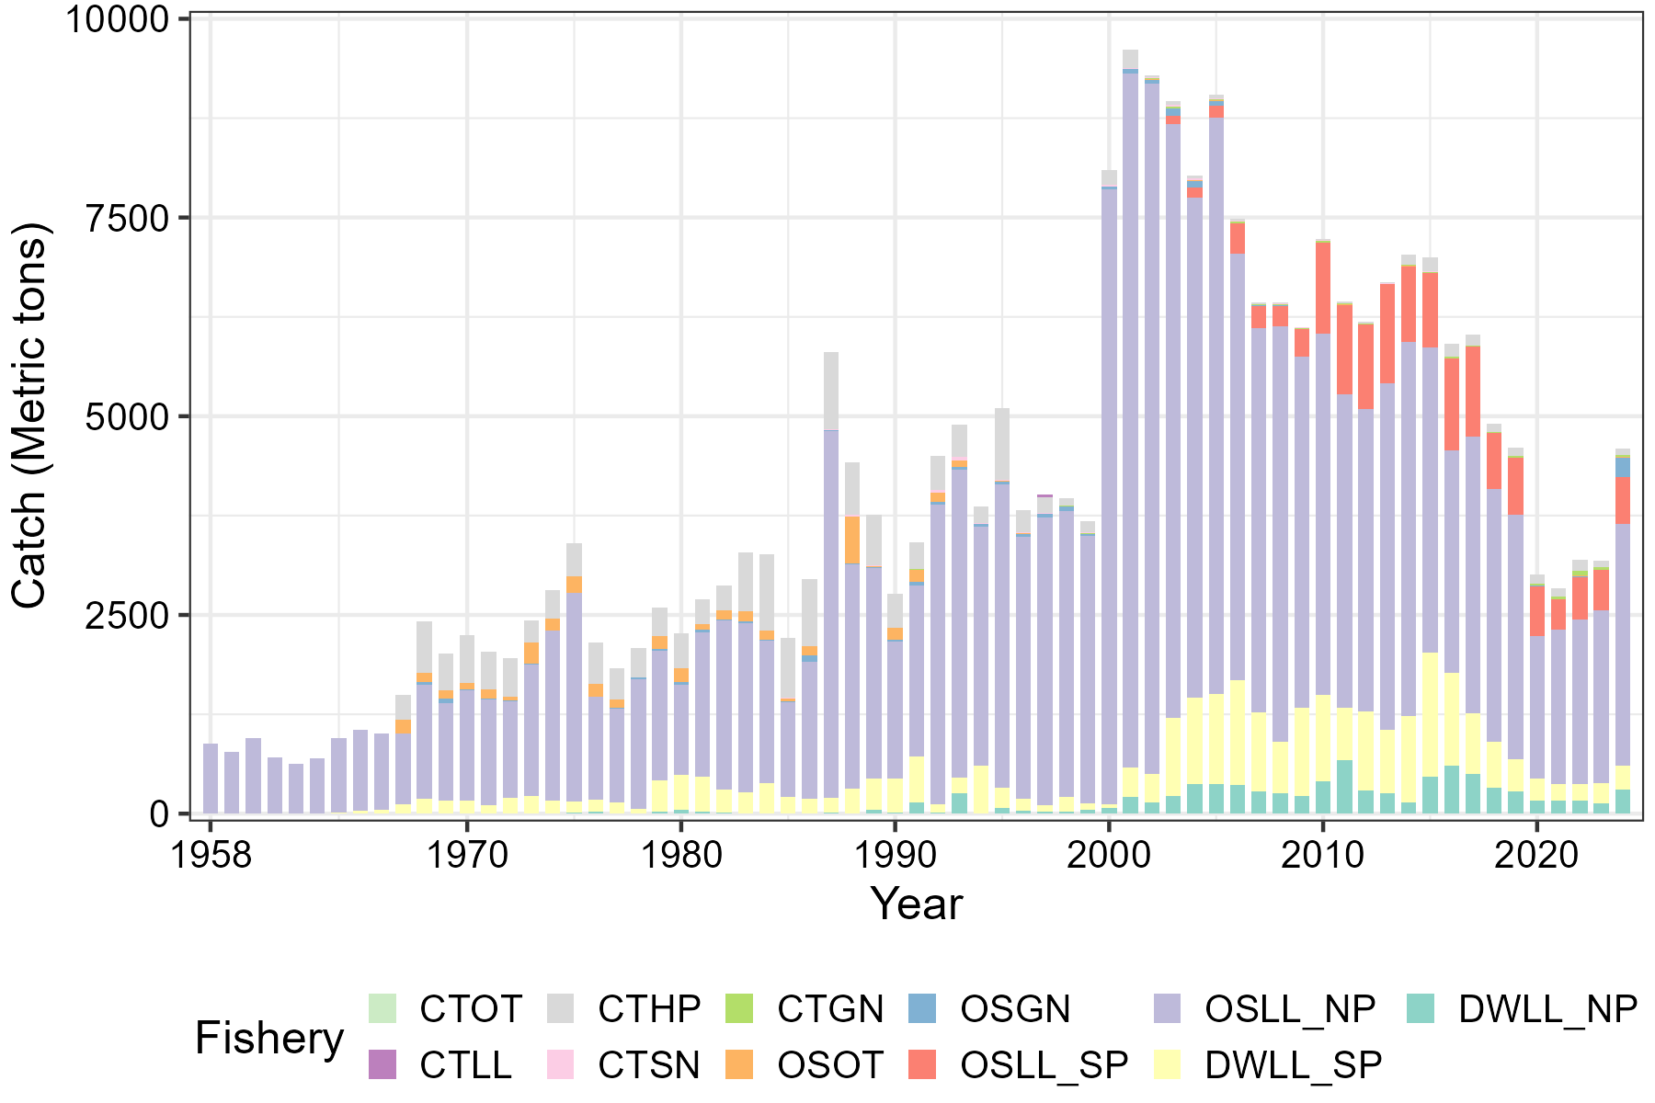
Figure 1. Catch estimates of blue marlin by the Taiwanese fisheries in the Pacific Ocean. DWLL: distant-water tuna longline; OSLL: offshore longline; OSGN: offshore gillnet; OSOT: offshore others; CTGN: coastal gillnet; CTSN: coastal set-net; CTHP: coastal harpoon; CTLL: coastal longline; CTOT: coastal other fisheries.
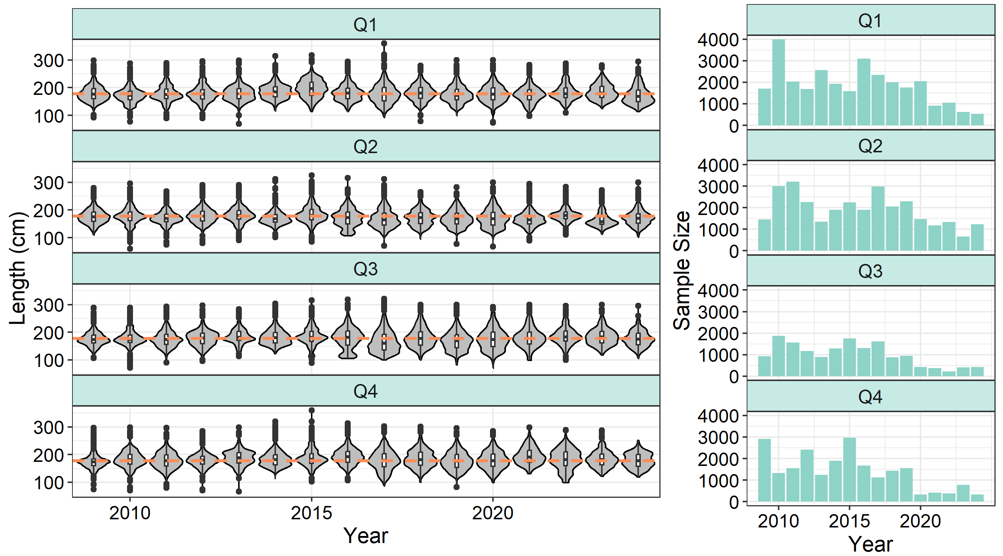
Figure 2. Length frequency distribution by year-season for blue marlin caught by the Taiwanese distant-water tuna longline fishery in the Pacific Ocean. The left panel shows violin plots of length distributions by season across years, while the right panel presents the sample sizes by season across years.
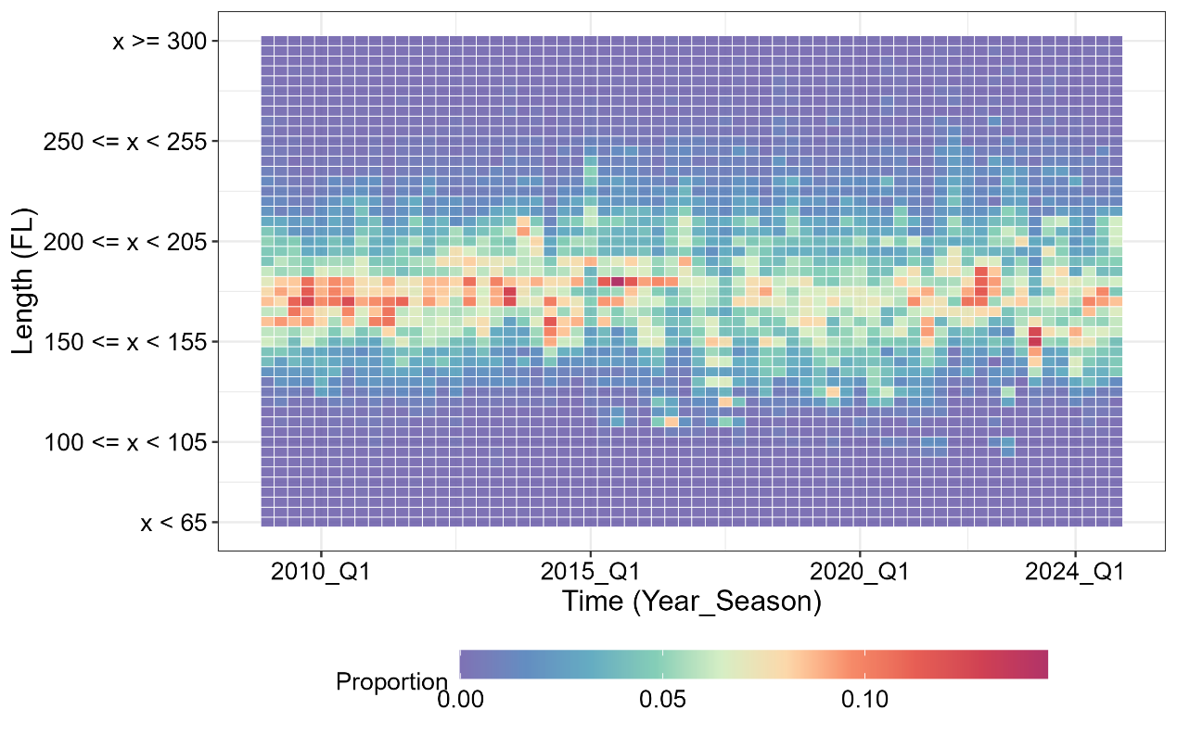
Figure 3. Length frequency heatmap by year-season for blue marlin caught by the Taiwanese distant-water tuna longline fishery in the Pacific Ocean.

